**VS-Code Assignment**

**Unit-test testcases:**

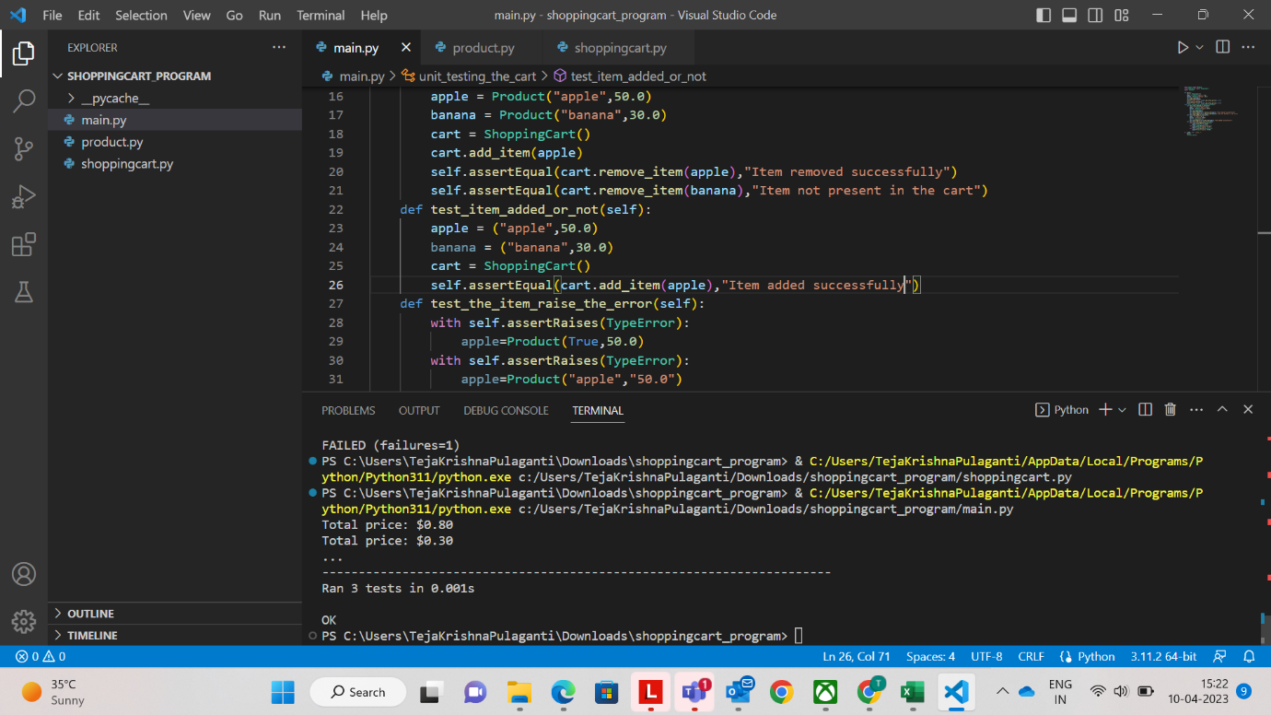

**Extensions Used in VS-code:**

**Python**



**Python Preview**

